- Overview

- General Design Guidelines

  - Windows Containing Tabular Information

The application will display data from various database tables. As a general rule, these windows should have the following characteristics:

- when the window is resized the columns should adjust their widths accordingly
- the row should be highlighted when one of its cells is single-clicked
- the row should be selected for further activity when one its cells is double-clicked
- when a record is highlighted, using the ‘up’ or ‘down’ arrow keys will move the highlight to the previous or next record
- the table can be resorted (both in order and reverse order) by clicking on the corresponding column-header label
- the columns can be rearranged by dragging the column-header label to a new position

  - “Update” Windows

Some application windows are designed to display data for the purpose of updating the database. The fields in these windows will typically be populated with existing data. The input fields should generally have the following characteristics:

- Character fields should have trailing spaces truncated prior to being displayed

  - Determining Database Metadata

The user will be given the ability to change data within a number of different database tables. If possible, the program should be aware of the length of the character fields, and the size of the numeric fields within the tables, so that users are not allowed to key more data into a field than the database allows.

  - Internal Calculations

Internal whole-number calculations should generally use “int” variables (rather than “short” variables), even if the associated display fields require a tighter limit. This will provide flexibility in case future enhancements indicate a need to relax the field-level limits.

Internal dollar-and-cent calculations should generally use a class like “BigDecimal” instead of float or double variables, since floats and doubles sometimes have rounding issues when storing larger values.

  - The Short-SKU Field

In the Store RF application, the Short-SKU field typically contains either a short-SKU (which has a value between 1 and 8 digits), a UPC (12 digits), or an EAN (13 digits). Within the various database tables, the short-SKU is ideally stored in a decimal(13,0) column. However, because of legacy factors, it is sometimes split up and stored within two integer columns. The split logic works as follows: The 8 least-significant digits are stored in a “sku” column, and the remaining digits are stored in a “sku-overflow” column. So if the represented value is a short SKU, it is entirely stored within the sku column, and a zero is stored in the sku-overflow column. If the number is a UPC, the bottom 8 digits are stored in the sku column, and 4 digits are stored in the sku-overflow column. With an EAN, 5 digits are stored in the sku-overflow column.

All of this should be transparent to the user, who should see the SKU displayed as a single entity.

Behind the scenes, when necessary the code may need to select the two distinct columns and join them for display purposes. Any updates to the database using the short SKU as a key may require re-splitting the sku prior to performing the SQL statement.

  - Audit Trail

The program should create some sort of audit trail, so that it is possible to review this log and determine things like “Who logged in”, “What type of activity did they perform”, “What did they change”, and “When did they do it?“

- Environment

The application currently resides within the directory structure c:\rwb (Retail Workbench). This directory is transparent to the users.

The Java-based application should reside within the directory structure defined by the application configuration file (see below).

- Configuration File

The Java app should minimize the use of hard-coded values. Instead it should use the application configuration file as much as is practical, and environment variables when it makes sense.

The configuration file should have the following format:

Setting1=abc 123
Setting2=45
Setting3=c:\directory

Where “Setting1” is a program setting (i.e., variable), and “abc 123” is the assigned value.

Some of the actual program settings are likely to be…

AppRoot=c:\jrwb (Java Retail Workbench)
StoreList=StoreList.txt
SupervisorLevel=3

- Invoking the Program from the Desktop

The application should be launched from an icon on the desktop, and this icon should point to a batch file. The batch file should set the necessary environment variables (including one pointing to the configuration file), and launch the program.

- Startup Activities

When the program is invoked, it should first examine the contents of the “Store List” file (defined in the configuration file). This file contains one or more rows, each row containing two columns. Column #1 is the name of the Unix server, and #2 is the store number.

If the list contains a single store, the store-selection logic should be skipped.

If, however, more than one store exists, e.g….

nmposdev1 13
nmrftst1 2
nmrftst2 22
nm102 102

…the program should display a store-selection dialog box. The current application displays a box like this:

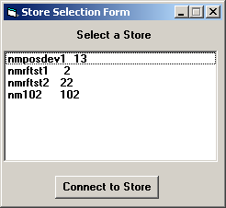

(The fact that the two columns don’t line up properly is not by design.)

The user should be able to select a store by 1) single-clicking on the desired row then pressing “Connect To Store”, or 2) by double-clicking on the desired row.

- The Main Menu

Prior to displaying the main menu, the program should perform some sort of validation activity to confirm that the application is able to connect to the associated database. If the validation is not successful, the program should display an error message, allow the user to acknowledge it, then exit. If needed, the program can put up a “please wait…” message while performing this action.

The main menu currently looks like this:

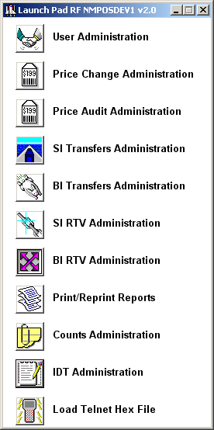

Note: If more than one store exists in the Store List file (see above), the program should also float a small window identifying the selected store. For instance, if the selected store is 12, the window should display “Store #12”. This floating window should remain until the program is terminated.

